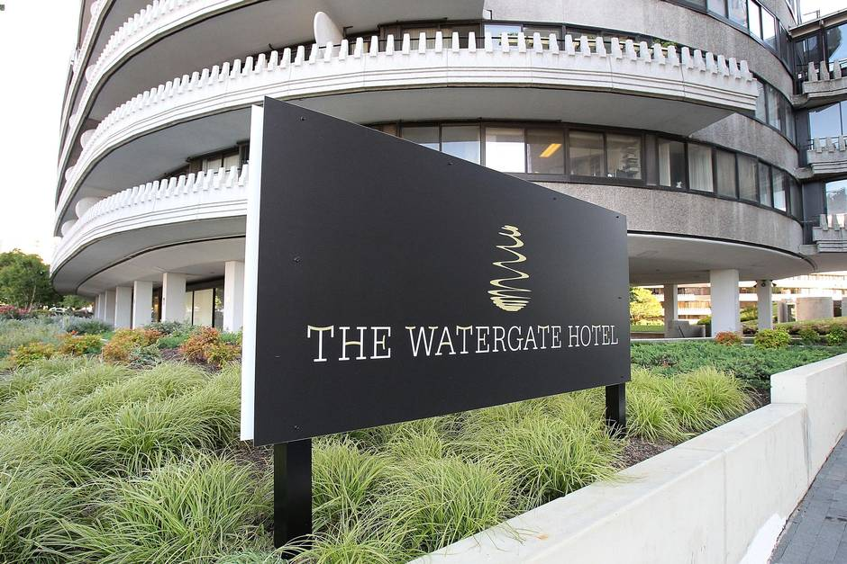
Announcing From Quantum to Cosmos-7: NASA 2022 Fundamental Physics Experiments in Space Workshop

On behalf of the organizing committee, we have the pleasure to announce that From Quantum to Cosmos-7 will be held in person Mar 29-31, 2022, at the Watergate Hotel, 2650 Virginia Ave NW, Washington, DC 20037, USA. This will continue the tradition of Q2C workshops started in 2006.

The NASA home for laboratory fundamental physics in space research moved from the Human Explorations and Operations Mission Directorate to the Science Mission Directorate in 2020. With this move there is a renewed focus on transformative science and encouragement of new mission development in our parent organization, the Biological and Physical Sciences Division. NASA plans to increase the support provided to U.S. space fundamental physics researchers through regular solicitations, starting in 2022. The focus of the initial solicitation will be to select investigators for ISS Cold Atom Laboratory research using a new planned science module (SM4), and to select ground-based investigations for potential future flight experiment formulation, development, and implementation. This workshop will provide a forum for the community to learn about NASA’s plans to build a vigorous program of basic research supporting space-based experimental physics.

At the workshop fundamental physics scientists and technologists will share new results and present and discuss pioneering research ideas for future space experimentation on the ISS, the Lunar Gateway, Free Flying Satellites, and the Lunar surface. The workshop will focus on theory and experimental research in the following thematic areas: Quantum Matter, Quantum Entanglement, Gravitation, Dark Energy, Dark Matter, Complex Plasma, Lunar Dust and Plasma, and Other Space Fundamental Physics/ Technology. Many of these areas are the subjects of intense interest and active research by other divisions within the NASA Science Mission Directorate. The aim of this workshop is to promote the development of space-based experimental approaches to the leading questions in physics.

The workshop agenda will include Keynote talks, invited and contributed presentations, and a poster session. Interested scientists, technologists, and government agency representatives are invited to submit abstracts to be considered for contributed presentations. The participation of the current NASA-funded investigators or their representatives is kindly requested.

The workshop website - http://icpi.nasaprs.com/FPWS2022 - includes detailed registration, abstract submission, and venue information. Please take a moment to register your interest for the workshop. There is no registration fee to participate.

Abstract Deadline is Jan 31, 2022 and presentation acceptance letters will be sent Feb 28, 2022

We look forward to seeing you in person at the workshop in Washington D.C.
Ulf Israelsson, JPL
Brad Carpenter, NASA BPS
Co-chairs, Organizing committee

